# MediCue 24/7

Submitted in partial fulfillment of the requirements of the degree

**BACHELOR OF ENGINEERING** IN **COMPUTER ENGINEERING**

By

**Student Name1**

**Anupam Kumari**

**Reg/Roll No. 23**

**Student Name2**

**Anushka Mandrawliya**

**Reg/Roll No. 26**

**Student Name3**

**Patil Gauri Rajendra**

**Reg/Roll No. 39**

Name of the Guide

**Prof. Ranjit Mane**

Institute’s LOGO

**Department of Computer Engineering**



**Bharati Vidyapeeth College of Engineering.**

**Sector 7, CBD Belapur, Navi Mumbai, Maharashtra 400614**

**University of Mumbai**

**(AY 2021-22)**

# CERTIFICATE

This is to certify that the Mini Project entitled **“*Medicore24/7*”** is a bonafide work of ***Anupam Kumari, Anushka Mandrawliya, Patil Gauri Rajendra*** submitted to the University of Mumbai in partial fulfillment of the requirement for the award of the degree of **“Bachelor of Engineering”** in **“Computer Engineering” .**

## (Prof. Ranjit Mane)

Project Guide

## (Prof. Dr. Dayanand Ingle ) (Prof. Dr. Sandhya Jadhav)

Head of Department Principal

# Mini Project Approval

This Mini Project entitled “***Medicore 24/7*”** by **Anupam Kumaril (Roll no-23), Anushka Mandrawliya (Roll no-26), Patil Gauri Rajendra (Roll no-39)** is approved for the degree of **Bachelor of Engineering** in **Computer Engineering.**

**Examiners**

**1…Ranjit Mane……………………………………**

(Internal Examiner Name & Sign)

## 2…………………………………………

(External Examiner name & Sign)

Date:Place

# Contents

## Abstract

## 1 Introduction

* 1. Introduction
  2. Motivation
  3. Problem Statement & Objectives
  4. Organization of the Report

1. **Literature Survey** 
   1. Survey of Existing System/**SRS**
   2. Limitation Existing system or Research gap

## Proposed System (eg New Approach of Data Summarization)

* 1. Introduction
  2. Architecture/ Framework
  3. Algorithm and Process Design
  4. Details of Software
  5. Analysis
  6. Conclusion and Future work.

## References

## Abstract:

## Health has became our prime priority after the outbreak of Covid-19 pandemic and now people do their checkups regularly also the number of diseases are increasing due to our unbalanced lifestyle which forces the people to take many kinds of pills, syrups etc. In a 2017 high level study involving 1,198 adults, they were found to have medication delays 80–85 percent of the time and to have forgotten medication 44–46 percent of the time and it was found that the statistics are at peak incase of senior citizens as they already have many health problems like Alzheimer sans all. So here comes our MediCue 24/7 app in action. The MediCue 24/7 medication reminder is a straight-forward having clean interface and easy to use, user friendly smartphone app. You’ll get pop up notifications with sound about when to take your medications and receive medication reminders. If you miss a dosage (and don’t respond to several alerts) , you will also receive push notifications. There is an inbuilt reminder with calendar and clock in our app which will make it easy for aged people to use. Also it has many other functions which will help the mankind a lot.

## Keywords: Medicines, Reminder, Android Development, Android Studio, Java.

## ****“Time and Health are two precious assets that we don’t recognize and appreciate until they have been depleted.”****

## – Denis Waitley

## Introduction

## Introduction: MediCue 24/7 is a free app for medication reminding. But infact it is more than that. It is the result of hardwork of our team members who worked very closely with the people taking medications in order understand their needs. If a person forgets about his previous medicines then he can go in the Reminder History to check it again. MediCue 24/7 app is for you whether you are taking antibiotic medicines or living with long standing diseases like Cancer, Hypertension, Anxiety or Depression.

## MediCue 24/7 is your path to peace of mind, with a medicine reminder which will surely help you to improve your health conditions. We understand that there is no other substitute for

## good health and so it’s very important for you to take your medications on regular basis without skipping them inorder to get well soon!

## Motivation: We got stimulus by seeing the helpless condition of senior citizens living around us, some already having memory destroying disease like Alzheimer’s disease and there is no one to take care of them or atleast to remind them to take atleast their medications daily. So we felt that we should do something or the other for those helpless patients so that they can be saved from mini panic attacks and other arising mental health problems which path their way just because these people miss their daily doses of medicine.

## Young people too sometimes forget to take their pills due to excess work stress and daily problems in their lives. So we came up with this quick fix and created a reminder app by using our knowledge of computer field and by extensively searching about our project on internet inorder to get more information and to make best out of what we know and by using the available resources.

## Problem Statement and Objective: Many diseases last longer just because we don’t give them necessary attention and let them spread in our body. And what we found from our extensive research that the main reason behind neglecting our own health is by not taking our medications seriously, avoiding them when we need them the most and this leads to serious, critical conditions and may lead to death too.

## So our main objective is to make people aware of what mistake they are making by not taking their medicines on time. Our MediCue 24/7 app can be a life savior for many humans to tend to forget things unintentionally.

## Organization of report: This report is made for the sake of giving the brief insight of our mini project. Main problems highlighted in this report are related to medical system and we also tried to provide a robust solution for it by the means of our app.

## Technologies used to create this project include application of android development, Java language, github - an open source platform etc.

## Literature Survey

* 1. **Survey of Existing System/SRS:** We designed our app after studying in deep about the other existing system that are already available in the market but are having some or the other apps.

We came across many gadgets that are having a reminder in-built in them like Tabtime Timer- this is a gadget just like a wrist watch having reminder and some other facilities in it but the stumbling block in it is that we have to separately purchase it by spending some extra money plus it is not that handy and easy to use for senior citizen when compared to our app as our MediCue 24/7 app is having a clean interface which anyone can understand easily also we are not charging any cost for downloading it. Anyone can use it irrespective of their financial status.

There are few other softwares with the same theme but are not that effective and they all are not free and charge a lot. Our objective is very simple; we think that such systems like our app must be provided with no charges inorder to benefit the mankind.

* 1. **Limitations in existing system or Research gap:** We went through many users complaints about the existing apps on the play store and following are the consumer grievances:
* Premium versions have unaffordable pricing plans
* People get frustrated by lots of advertisements on the app screen.
* In some apps user have to write the reminder data daily and that irritates them.
* Sometimes the app doesn’t show notifications and sometimes the sound of popping doesn’t come so they have to manually first check that what’s wrong with the app. We feel if the app fails to serve its only purpose then what the use of such apps is.
* People find the interface of some apps confusing; in some it’s difficult to delete the existing reminders of medications.

**3. Proposed System (eg. New Approach of Data Summarization)**

**3.1 INTRODUCTION:** The proposed system is based on Android Operating system which will remind the users to take medicines on time through notification and automatic alarm ringing system. Android is a Linux-based operating system designed primarily for touch screen mobile devices such as smart phones and tablet computers, developed by Google in conjunction with the Open Handset Alliance.

Android was built from the ground-up to enable developers to create compelling mobile applications that take full advantage of all a handset has to offer. The system is specified on android operating system only because the market share of Android is high. Android also comes with an application development framework (ADF), which provides an API for application development and includes services for building GUI applications, data access, and other component types.

**3.2 ARCHITECTURE / FRAMEWORK**: The framework is designed to simplify the reuse and integration of components. Android apps are built using a mandatory XML manifest file. The manifest file values are bound to the application at compile time. This file provides essential information to an Android platform for managing the life cycle of an application. Examples of the kinds of information included in a manifest file are descriptions of the app’s components among other architectural and configuration properties. Components can be one of the following types: Activities, Services, Broadcast Receivers, and Content Providers.

Also, in SYSTEM ARCHITECTURE Important (Main) Functions available in classes Alert() Function: performs an evaluation based on medicine time comparison and determine if alert is needed to remind user to take the medicine. Precondition: All values needed for evaluation are accessible to this function. Post-condition: Necessary evaluation is done successfully.

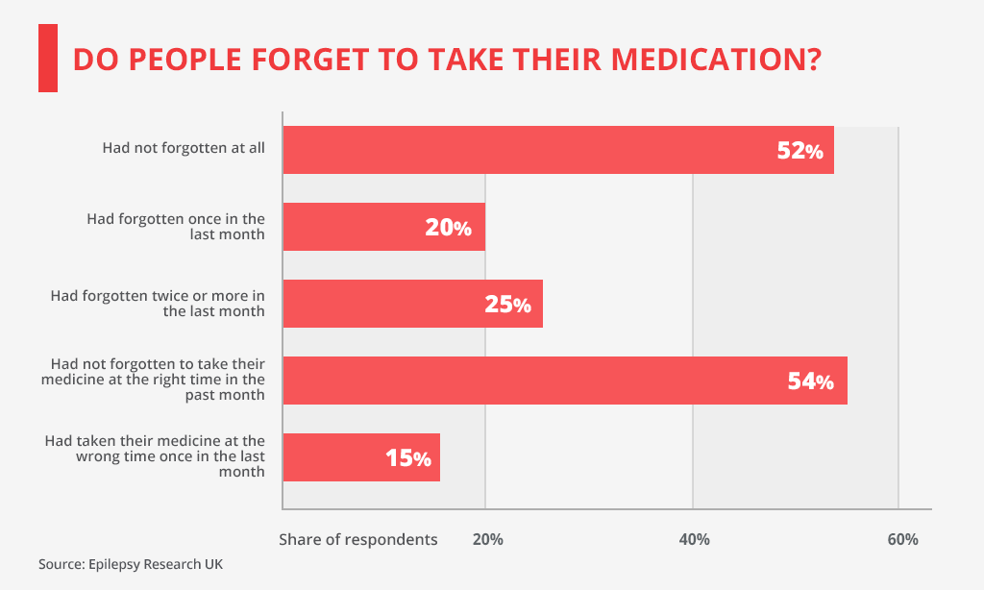

**Flow chart :**

**MediCue 24/7**

Medication Remainder

**Figure 1. Medication Reminder (MediCue 24/7) System Overview.**

**Algorithm and Process Design**

MediCue 24/7

(Interface)

Notification module

Set alarm

Add medicine

**Above flowcharts highlights the patient module. After the patient will be able to view and can successfully add medicine facility which included whatever prescribed medicine names has to be taken. The Reminder system consists of two parts –setting Alarm and getting notification.**

* 1. **Experiments and results for validation and verification:** As we know, through all of this research, we found the current market for medication reminder systems is missing a method that goes beyond a basic alarm, and that shifts the perception of the medicine taking experience away from the traditional view of being a negative nuisance to a positive and enjoyable one. This inspired MediCue 24/7, a medication reminder system that associates the medication taking experience with a positive trigger.. When a user receives a pill reminder, he or she will also receive a positive trigger. These triggers are used as an opportunity to cultivate a peaceful and positive experience to create an association between taking medication and feelings of tranquility and happiness.

**Add Medicine-** Below figure 1 shows where we can add our prescribed medicine successfully on tapping plus (+) icon.

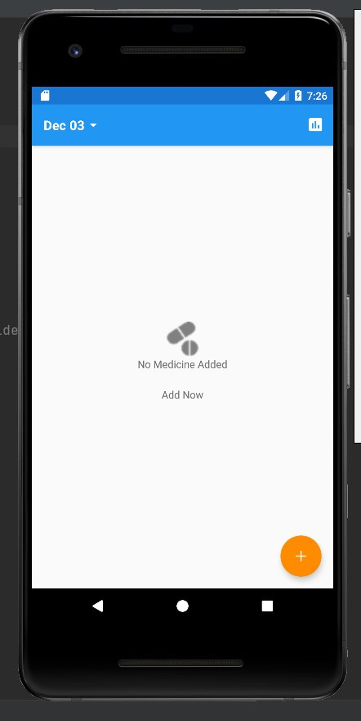 fig. 1

After tapping on plus icon we can see the interface in fig-2 where we can add patient’s daily requirements which includes:-

1. MEDICINE NAME
2. MEDICINE DAYS
3. REMAINDER

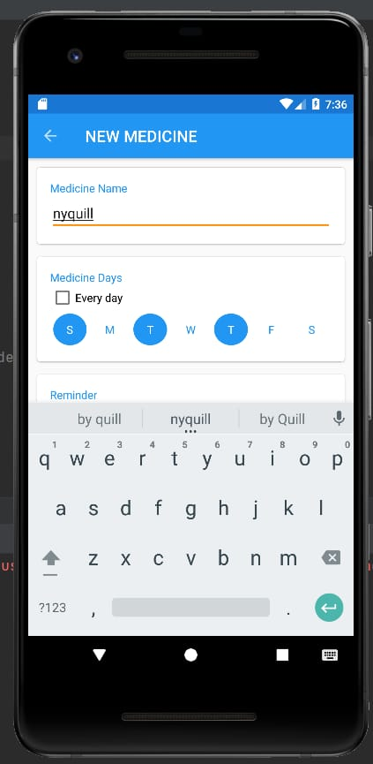 fig. 2

**Set alarm/remainder:--**

It helps in reminding about the medicines. User can add details of his dosage schedules. Using the days field shown in (fig-2) one can enter the days between which he has to take medicines. The time field shows the time of dosage and on that time the alarm will get rung. The user can add the description of the medicine, including name(shown in fig-2). All the information will be saved in the database. This makes any time availability of the patient’s records.

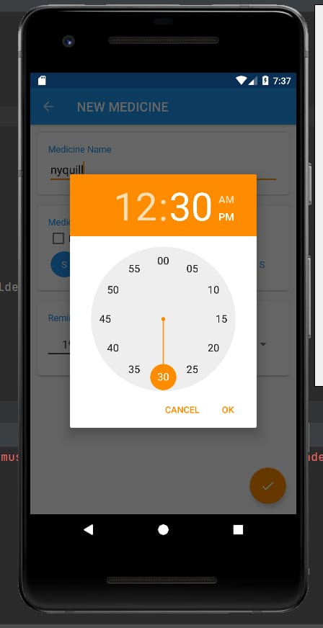 fig.3

**Get Notification module:**

Once the alarm is set then the user gets the notification. The users can cancel accordingly. If he does not require the notification he/she can cancel it shown in fig 4.

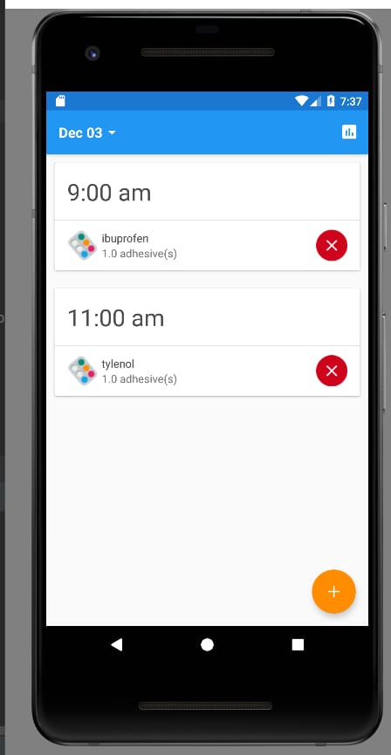 fig.4

**Fig -5** shows the calendar facility where he can/she can check the suitable date according to their preferences of medicine doses.

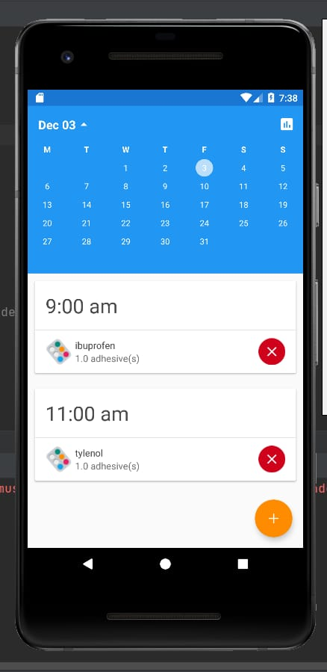

* 1. **Details of software:** The user of this software product will be interfacing with the Medicine Reminder application system to help remembering the medicine that he/she is going to take. The product allows user to use a reminder application only specified for medicine usage which eases the remembering of time, medicine name for the users. There are 5 interactive pages in this application listed below: Home Page Add Reminder Page Remove Reminder Page List Reminder Page Reminder Logs.

This application is written in Android. Java language was used to implement the project. The main software interfaces included in MediCue 24/7:

GitHub is a kindly **code hosting platform for version control and collaboration**. It lets you and others work together on projects from anywhere. This tutorial teaches you GitHub essentials like repositories, branches, commits, and pull requests. You can use organizations for free, with GitHub Free, which includes **unlimited collaborators on unlimited public repositories with full features**, and unlimited private repositories with limited features.

An android developer uses **analytical skills and computer training to develop systems for android devices**. ... Using a variety of tools to write program code in order to design and build applications for Android products. Also users collaborate with other teams to design new features that users need.

Android Studio provides **a unified environment where you can build apps for Android phones, tablets, Android Wear, Android TV, and Android Auto**. Structured code modules allow you to divide your project into units of functionality that you can independently build, test, and debug. The official language for Android development is **Java**. Large parts of Android are written in Java and its APIs are designed to be called primarily from Java. It is possible to develop C and C++ app using the Android Native Development Kit (NDK), however it isn't something that Google promotes.

One of the most widely used programming languages; Java is used as the **server-side language for most back-end development projects**, including those involving big data and Android development. Java is also commonly used for desktop computing, other mobile computing, games, and numerical computing.

* 1. **Analysis:** Additionally, it includes specific information about the expected input, output, classes, functions and their relationship with each other. The relation between the objects is shown above in detailed explanation and screenshots for desired requirements in a better way. . When applying this model to our application, this data can be collected and used to provide customized solutions to users. So overall analysis is based upon that is: ***This simple and easy-to-use app allows users to track their medications, receive alerts as reminders to take their pills, and set reminders for medical appointments.***

***It can also be used by the registered user to track, collect and share the past and present information regarding their health or the health of someone you care.***

We discuss this more in the Future Work section below.

***With the use of this recording tool, one can save money and other inconveniences like repeating several medical tests5% of people in the age group of 18-29 years have health applications installed on their smartphones. Moreover, this number is 8% for users in the age group of 30-49 years.***

***25% of senior citizens in the India are currently using a health application on their smartphones.*** Other interesting results included the types of people who are predicted to run out of medication. We also found that less educated patients and those who receive medication by mail are more likely to run out of medication.

***In a 2017 high level study involving 1,198 adults, they were found to have medication delays 80–85 percent of the time and to have forgotten medication 44–46 percent of the time.***

The figures below show that adults with more education are more likely to forget to take medication. Additionally, patients who have most recently started a new medication are also more likely to forget, making them a great user group to target when distributing this application

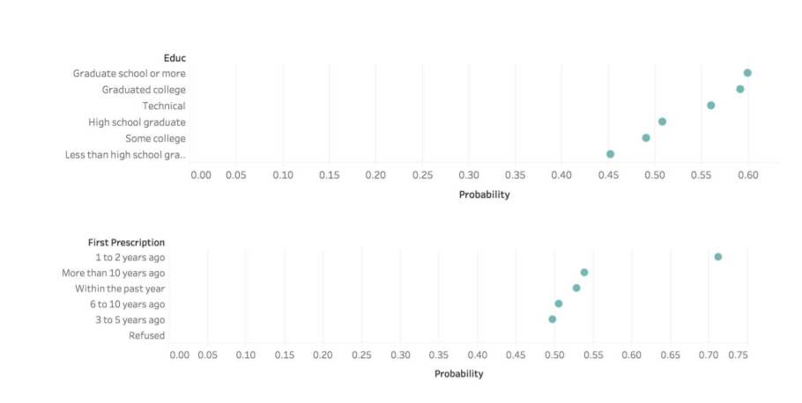

**3.6 Future work & conclusion:** Due to pandemic the whole world is shifting towards digitalization and our medical field should do the same. Still there are many villages in India where you don’t get proper medical treatment, but now our medical facilities can reach there with the help of internet and they can get best of the treatments and advices of professional doctors. Many applications are building where doctors and other medical professionals can have one to one conversation with the rural people.

Even if our app still gives reminder of medications for now but we are planning to add more new brainstorming features to our MediCue 24/7 app like the patient’s progress tracker, with the help of sensors we will be able to track the people having our app in their devices if they get lost somewhere and will be able to track by their families, we will also try to insert some software that will keep tracks of your prescriptions and will remind you when it’s time for them to refill and there are many more such great ideas which are in our minds and we will surely convert this Mini Project into a Major Project in our upcoming semesters.

**References:**

* <https://www.udacity.com/course/android-basics-user-interface--ud834>
* <https://github.com/>
* <https://www.javatpoint.com/android-tutorial>
* <https://youtu.be/mXjZQX3UzOs> (Tutorials)
* <https://developer.android.com/courses>